Safeguarding Policy for HAWKS HOCKEY CLUB

Hawks Hockey Club is a registered Charitable Incorporated Organization (CIO)

Introduction
HAWKS HOCKEY CLUB is a field hockey club that welcomes players of all ages, abilities, and backgrounds. We are passionate about the sport and the benefits it can bring to our physical, mental, and social wellbeing. We recognise that some people may be at risk of abuse, neglect, or harm, either within or outside the club. Therefore, we are committed to creating a safe, supportive, and inclusive environment for everyone involved in our club.
Hawks Hockey Club adheres to the England Hockey Safeguarding, Good Practice, Policy, and Procedure.
This safeguarding policy outlines our approach to protecting the welfare of children and vulnerable individuals involved in our club.

Key Principles
- Responsibility: Trustees and all members, coaches, volunteers, parents and any other people coming into contact with the charitable incorporated organisation, share the responsibility for safeguarding. Trustees will promote an open and positive culture and ensure all involved feel able to report concerns, confident that they will be heard and responded to.
- Awareness: We promote awareness of safeguarding issues and provide relevant training. The trustees will make sure all staff, coaches, volunteers, parents, guardians and any other people coming into contact with the charitable incorporated organisation, understand safeguarding and their right to be safe in accordance with the Charity Commission Regulatory and Risk Framework
- Reporting: Any concerns or incidents must be reported promptly to the designated Welfare Officer. The Charity Commission requires any registered charity to report ‘serious incidents’. The trustees will take responsibility for reporting ‘serious incidents’ with the Charity Commission, even if it is delegated to someone else, such as the Welfare Officer.
- Procedures: We follow England Hockey’s Safeguarding, Good Practice, Policy and Procedure to safeguard and protect Young People in Hockey. The Trustees will promote an open and positive culture and ensure all involved feel able to report concerns, confident that they will be heard and responded to.

Our Aims
By following England Hockey’s Safeguarding, Good Practice, Policy and Procedure, Hawks Hockey Club aims to:

- Ensure that the safety and welfare of children, young people, and vulnerable adults is paramount in all our activities
- Comply with the England Hockey Safeguarding Young People Policy, Procedures and Good Practice Guidance, the England Hockey Safe Hockey guidance, and the relevant legislation and statutory guidance
- Adopt and implement the England Hockey Code of Ethics and Behaviour, which sets the standards and values that apply at every level of hockey
- Appoint a Lead Welfare Officer and one or more additional Welfare Officers, who will be responsible for coordinating and overseeing our safeguarding policy and activities
- Ensure that all our staff and volunteers who work with children, young people, and vulnerable adults have appropriate Disclosure and Barring Service (DBS) checks and safeguarding training
- Provide clear and accessible information and guidance on safeguarding issues to our members, staff, volunteers, parents, and guardians
- Encourage and enable our members, staff, volunteers, parents, and guardians to report any concerns or disclosures of abuse or harm, and to respond to them promptly and appropriately
- Prevent and address any forms of bullying, harassment, discrimination, or abuse that may occur within or outside the club
- Monitor and review our safeguarding policy and activities regularly, and seek feedback and suggestions from our members, staff, volunteers, parents, and guardians

Charity Commission & Trustees:
As Hawks Hockey Club is a registered Charitable Incorporated Organization (CIO) and as part of CIO governance, the trustees oversee safeguarding matters.
The club trustees is ultimately responsible for ensuring that the club has an effective safeguarding policy and that it is implemented and monitored.
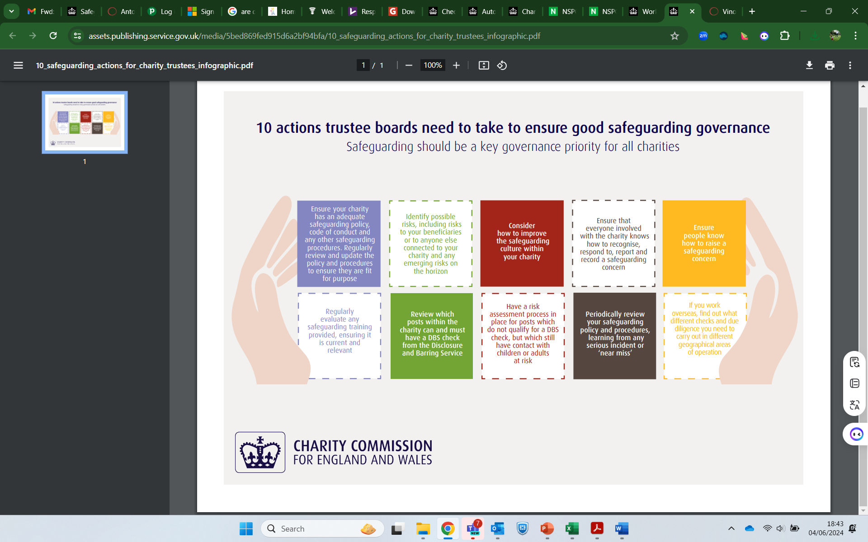
10 actions our trustees will take to ensure good safeguarding governance.
- Ensure safeguarding will be a key governance priority for our club.
- Ensure the charity has an adequate safeguarding policy, code of conduct and any other safeguarding procedures. Regularly review and update the policy and procedures to ensure they are fit for purpose.
- Identify possible risks, including risks to our beneficiaries or to anyone else connected to our charity and any emerging risks on the horizon.
- Consider how to improve the safeguarding culture within our charity.
- Ensure that everyone involved with the charity knows how to recognise, respond to, report and record a safeguarding concern.
- Ensure people know how to raise a safeguarding concern.
- Regularly evaluate any safeguarding training provided, ensuring it is current and relevant.
- Review which posts within the charity can and must have a DBS check from the Disclosure and Barring Service.
- Have a risk assessment process in place for anyone who does not qualify for a DBS check but has contact with children or adults at risk.
- Periodically review our safeguarding policy and procedures, learning from any serious incidents or ‘near misses’.

Code of Conduct
Hawks Hockey Club will adopt the England Hockey Code of Ethics and Behaviour RESPECT policy. All members must adhere to the Code of Conduct, emphasising respectful behaviour and safeguarding principles.

Training
All coaches, volunteers, and Welfare Officers will complete the Safeguarding and Protecting Children qualification in line with England Hockey.

Review
This policy will be regularly reviewed, at least annually, to ensure its effectiveness.

